**Book carousels for blog posts**

Book carousels help showcase what items are on a display, including e-books and e-audiobooks. They are not required for blog posts, but add depth and help increase patron interaction with blog posts and displays. The carousel will combine multiple formats of each title and brings patrons to the catalog if selected.

1. Create an item record set with all the titles you’d like to include in your carousel. This does not necessarily just need to be the books that will be on display. Make sure the owner of the record set is ‘Manchester’.
2. In [Simply Reports](https://fusor.gmilcs.org/simplyreports/items.aspx), under the ‘Items’ tab, add **MARC title** and **MARC sort ISBN** to the columns for selected output. Optionally, you can also add **MARC Author**.
3. Under ‘Item general filters’, check the box for ‘Item record set’ and select your record set from the drop down. If you don’t see your record set, make sure the owner is set to ‘Manchester’ in Polaris and save it, then try refreshing Simply Reports.

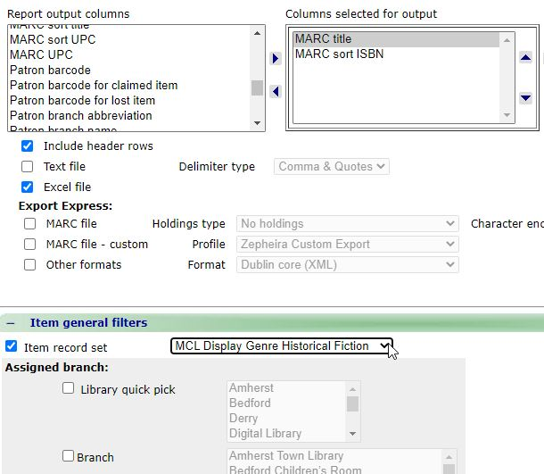

1. Click ‘Submit’ at the bottom of the page, and download the report.



1. Open the Excel spreadsheet and select ‘Yes’ if a message pops up.

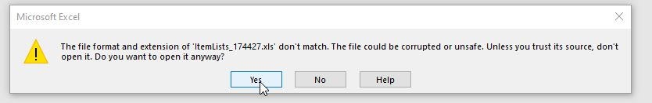

1. Select the ‘B’ column, change the ISBNs into numbers, and remove the extra decimal points

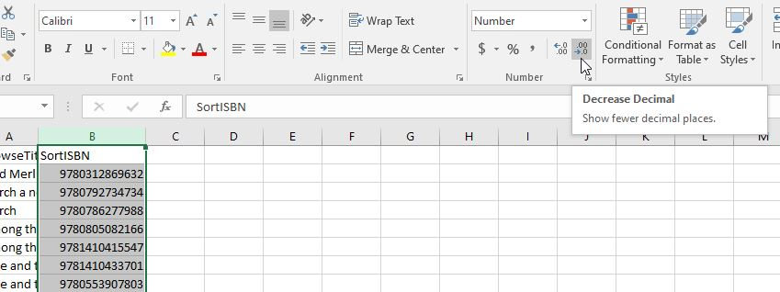

1. Under the ‘Data’ tab, click ‘Sort’ and sort by column A (BrowseTitle)

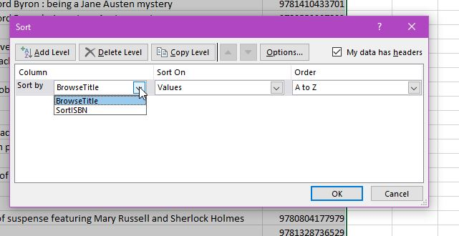

1. Make sure all the same titles are next to each other. Sometimes a different edition or ebook won’t include ‘a’ or ‘the’ and it won’t end up next to the print edition.
   1. If you find items with errors (incorrect author, missing ISBN, etc.), please let Alex P. know about them so he can update the records. Make a bib record set, set owner to Manchester, add the records that need adjustment, and let Alex know what the name of the record set is and what each title needs adjusted.
2. Capitalizing titles, removing extra words such as ‘a novel’ or subtitles, and fixing author names is optional, but keep in mind that what is typed is exactly what will be displayed in the carousel.
3. Open a new blank LD Carousel Code Template spreadsheet and save as to your H drive.
4. Highlight and copy all of your titles and paste them into column B, starting at row 4.

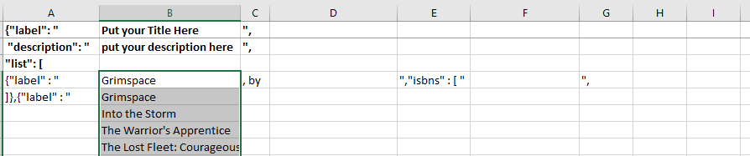

1. Highlight and copy all of your authors and paste them into column D, starting at row 4. If you did not include authors in your list, then ignore this step. 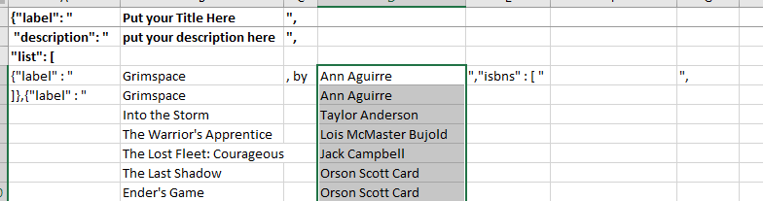
2. Highlight and copy all of your ISBNs and paste them into column F, starting at row 4. 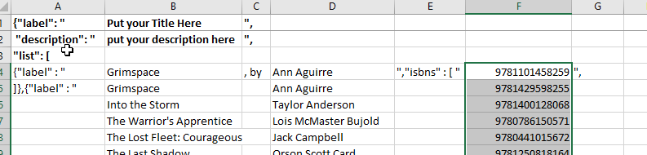
3. Copy the information in cells A5, C4, E4, and G4 so that it runs to the end of list. Select the cell and hover your mouse over the bottom right corner to get the + symbol, then click and drag to the bottom of the list.

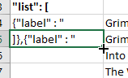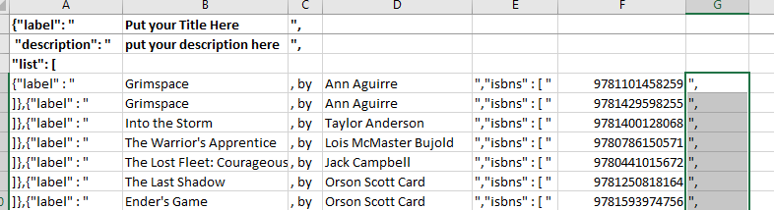

1. Follow these steps to format each set of titles into groups:
   1. Delete text in columns A, B, C, and D for any rows with duplicate titles. Leave the ISBNs.
   2. Replace the text in row E with a quotation mark.
   3. Delete the comma in column G for the last ISBN in that title’s set. 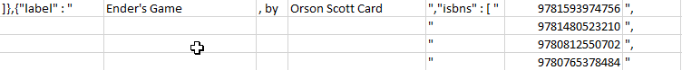
2. If there is only one ISBN for a title, delete the comma in column G after that ISBN.
3. If there is any space left between your list and the text in cell A60, delete the rows in between. 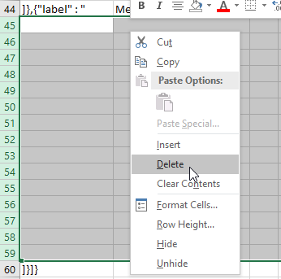
4. Fill in the title and descriptions as appropriate in cells B1 and B2.
5. If you did not include authors in your list, then move the text in cells C1 and C2 to E1 and E2, then delete columns C and D. Skip this step if your list includes authors.

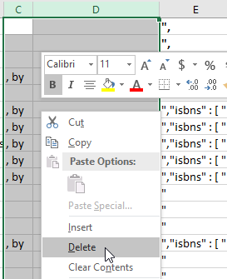

1. Copy all text and paste into new blank notepad document. Save the document as a .json file. Be sure to select ‘all files’ when saving, or it will save as a .txt file. Also make sure your encoding is set to UTF-8.

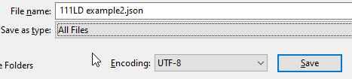

1. Delete all tab spaces by following these steps:
   1. Highlight the space between the open quotation mark and your title. 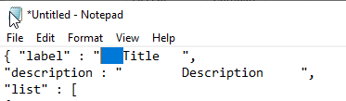
   2. Select Edit, then Replace

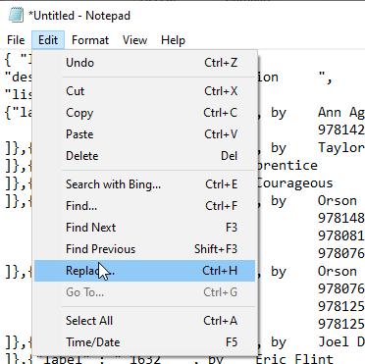

* 1. Leave the ‘replace with’ field blank, and select ‘Replace All’

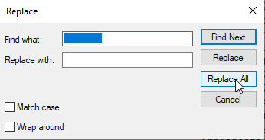

1. Once completed, look through for any errors. To double check, copy and paste the whole thing into this website: <https://json-ld.org/playground/>

Mistakes will show up with a red x but it won’t tell you what it is. It will likely be a missing or extra “ or ,.

1. After correcting any mistakes, upload the .json document to github: <https://github.com/GMILCS/MCL>
2. Once uploaded, click commit so save it. Next open the blank carousel .txt document saved in REF Schedules > Display schedule > Blank Carousel
3. Save this to your H drive as the title of your carousel. It should default to a .txt file, which is what it should be.
4. Find the word FileName in the document, and replace it with the name of the .json file uploaded to github. Make sure there are no extra spaces or punctuation.

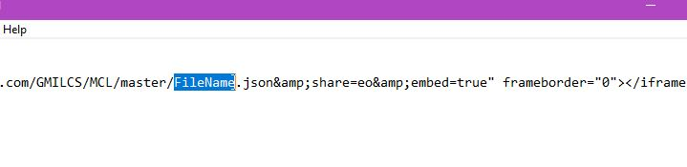

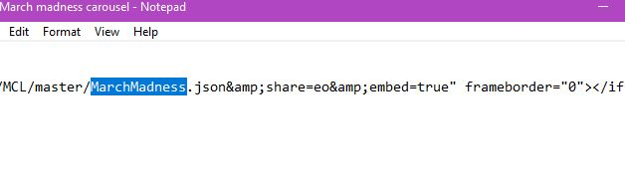

1. The .txt file is what will be used in the blog post. Please attach as a separate file when you send your post to YL. To preview the carousel, use this link below and replace FileName with the name of your .json document, no spaces:

http://collections.library.link/services/lister/?domain=http://link.manchesterlibrary.org/&list=https://raw.githubusercontent.com/GMILCS/MCL/master/**FileName**.json

For example:

<http://collections.library.link/services/lister/?domain=http://link.manchesterlibrary.org/&list=https://raw.githubusercontent.com/GMILCS/MCL/master/MarchMadness.json>

That link will **not** work on the blog because WordPress is picky and doesn’t like it.